- Question 1 of 10
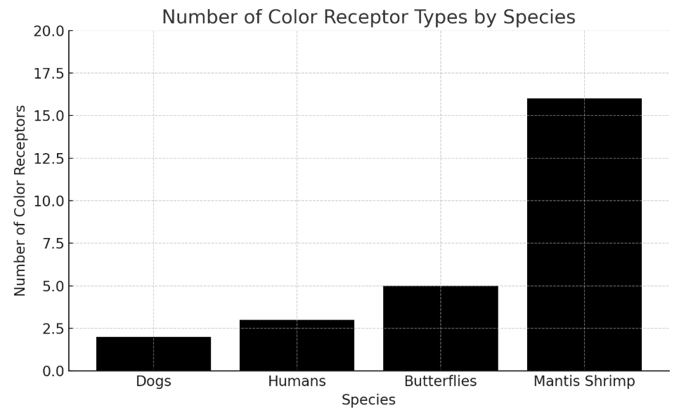
Scientists studying animal vision examine photoreceptors, specialized cells that detect different wavelengths of light. Species with more photoreceptor types can generally perceive a wider range of colors. While humans use three types of color receptors to see the visible spectrum, other species have evolved dramatically different visual capabilities. For example, the graph shows that the mantis shrimp’s visual system is ______

Which choice most effectively uses data from the graph to complete the example?
more complex than humans', with about 13 more color receptor types.
less complex than butterflies', with about 11 fewer color receptor types.
less complex than humans', with about 13 fewer color receptor types.
more complex than humans', with about 11 more color receptor types.

Question 2 of 10
Pareidolia is a psychological phenomenon in which the brain perceives familiar patterns, especially faces, in random or ambiguous stimuli. Researchers have found that this tendency is not a flaw in perception but rather an adaptive trait, as humans who could quickly identify ______ and potential threats in their environment had a survival advantage.

Which choice completes the text so that it conforms to the conventions of Standard English?
faces: food sources,
faces food sources
faces food sources,
faces, food sources,

Question 3 of 10
In 1969, tensions between Honduras and El Salvador erupted into a brief military conflict lasting approximately 100 hours. The war stemmed from disputes over migration and land ownership, but because it coincided with a heated World Cup qualifying series, it became known as “the Football War.” ______ historians emphasize that this nickname is misleading, as the true causes were rooted in migration policy and economic inequality rather than athletic rivalry.

Which choice completes the text with the most logical transition?
For example,
Consequently,
However,
Furthermore,

Question 4 of 10
Gresham’s Law, an economic principle often summarized as “bad money drives out good,” ______ that when two forms of currency are accepted at equal face value, people will spend the less valuable form and hoard the more valuable one. This phenomenon has been observed throughout history, from ancient Rome to modern economies.

Which choice completes the text so that it conforms to the conventions of Standard English?
have stated
were stating
states
state

Question 5 of 10
French artist Jean Dubuffet sought to ______ the distinction between trained and untrained artists by championing what he called “Art Brut,” or raw art. He believed that works created by self-taught individuals, psychiatric patients, and social outsiders possessed an authenticity that was often lost in academically trained artists, whose creativity he felt had been diluted by formal instruction.

Which choice completes the text with the most logical and precise word or phrase?
dismantle
circumvent
accentuate
reconcile

Question 6 of 10
The epistolary novel—a literary form in which the narrative unfolds exclusively through documents such as letters, diary entries, and written ______ experienced a surge in popularity during the eighteenth century, when authors like Samuel Richardson demonstrated the genre’s capacity for psychological depth and moral instruction.

Which choice completes the text so that it conforms to the conventions of Standard English?
correspondence;
correspondence—
correspondence,
correspondence

Question 7 of 10
Neurological research has increasingly challenged the assumption that perception is a fixed biological process, revealing instead that the brain can adapt to compensate for deficits in unexpected ways. Prosopagnosia, commonly known as face blindness, offers a compelling example of this adaptability. Individuals with this condition cannot recognize faces, even those of close family members, yet many navigate social situations with remarkable success. Researchers studying these individuals have found that they often develop heightened sensitivity to non-facial cues—voice patterns, gait, posture, and even clothing choices—that allow them to identify others. In some cases, individuals with prosopagnosia perceive subtle differences in movement or body language that most people overlook entirely, suggesting that perceptual limitations in one area may prompt enhanced processing in others.

Which choice best states the main idea of the text?
Prosopagnosia reveals that individuals who cannot recognize faces often develop heightened sensitivity to voice patterns, gait, and body language.
Research on prosopagnosia demonstrates that the brain can compensate for perceptual deficits by enhancing sensitivity in other areas.
Neurological research has shown that perception is not a fixed process, leading scientists to study conditions like prosopagnosia.
Individuals with prosopagnosia can navigate social situations successfully because they learn to identify people through alternative cues.

Question 8 of 10
Artist Robert Smithson, ______ to challenge the traditional gallery system and its commodification of art, created massive earthworks in remote landscapes that could not be bought, sold, or moved. His most famous piece, “Spiral Jetty,” remains embedded in the Utah salt flats, subject only to the forces of nature.

Which choice completes the text so that it conforms to the conventions of Standard English?
sought
seeks
is seeking
seeking

Question 9 of 10
William Shakespeare’s Hamlet explores the psychological complexity of its titular prince, who is tasked with avenging his father’s murder but repeatedly delays action. Scholars have long noted that Hamlet’s tendency toward philosophical reflection creates a paralyzing internal conflict; he recognizes that his habit of overthinking undermines his capacity for decisive behaviour, viewing contemplation itself as an obstacle to action. This self-awareness is evident when Hamlet states ______

Which choice most effectively uses a quotation from Hamlet to illustrate the claim?
"There is nothing either good or bad, but thinking makes it so."
"The play's the thing / Wherein I'll catch the conscience of the King."
"Thus conscience does make cowards of us all, / And thus the native hue of resolution / Is sicklied o'er with the pale cast of thought."
"O, that this too, too solid flesh would melt, / Thaw, and resolve itself into a dew!"
Question 10 of 10
The Pioneer anomaly puzzled scientists for decades after the Pioneer 10 and 11 spacecraft, launched in the 1970s, began drifting slightly off their predicted trajectories. Researchers initially proposed exotic explanations, including the possibility of unknown gravitational forces or even new physics. A more mundane cause was eventually ______ the uneven thermal radiation emitted by the spacecrafts’ power sources was creating a tiny but persistent push in one direction.

Which choice completes the text so that it conforms to the conventions of Standard English?
identified, however:
identified, however,
identified; however,
identified however,

SECTION B

Passage 1
The discovery of penicillin by Alexander Fleming in 1928 is often regarded as one of the most significant medical breakthroughs of the 20th century. Fleming’s chance observation of a mould that killed bacteria laid the foundation for antibiotics, which have since saved millions of lives. Before penicillin, even minor infections could lead to serious illness or death. However, the journey from Fleming’s initial discovery to the mass production of penicillin was not straightforward. It required the collaborative efforts of scientists such as Howard Florey and Ernst Boris Chain, who developed methods to purify and produce penicillin on a large-scale during World War II. Their work not only accelerated the availability of the drug but also revolutionized the treatment of bacterial infections, fundamentally altering the landscape of modern medicine.

Questions:
- The author primarily focuses on:
(A) The competitive nature of scientific discoveries.
(B) The role of penicillin in modern-day treatments.
(C) The significance and development of penicillin.
(D) The personal life of Alexander Fleming.
- According to the passage, why was the development of penicillin not immediate after Fleming’s discovery?
(A) Fleming refused to share his findings.
(B) The necessary technology had not yet been invented.
(C) Further research and collaboration were required to make it widely available.
(D) Penicillin was initially considered ineffective.
- The phrase “laid the foundation for antibiotics” most nearly means:
(A) Introduced a new method of surgery.
(B) Set the stage for the creation of antibacterial drugs.
(C) Encouraged competition among pharmaceutical companies.
(D) Improved diagnostic tools in hospitals.
- The author mentions Howard Florey and Ernst Boris Chain to:
(A) Highlight the contributions of lesser-known scientists.
(B) Emphasize that scientific progress often requires teamwork.
(C) Argue that Fleming’s role in the discovery was overstated.
(D) Show that penicillin was discovered independently by multiple scientists.
- The tone of the passage can best be described as:
(A) Critical and skeptical.
(B) Objective and informative.
(C) Humorous and light-hearted.
(D) Emotional and persuasive.

Passage 2:
The rise of renewable energy sources is transforming the global energy landscape. Solar and wind power, once seen as unreliable alternatives to fossil fuels, have experienced rapid advancements in technology and decreasing costs. Governments and private companies alike are investing heavily in renewable energy infrastructure, driven by the urgent need to combat climate change and reduce greenhouse gas emissions. In some regions, renewable energy now accounts for a significant portion of electricity generation. This shift is not without its challenges, however. Integrating renewable sources into existing power grids requires innovative solutions to manage variability and storage. Despite these hurdles, the transition to renewable energy continues to gain momentum, promising a more sustainable and environmentally friendly future.

Questions:
- What is the primary focus of the passage?
(A) The dangers of fossil fuel dependency.
(B) The increasing adoption and impact of renewable energy.
(C) The economic consequences of climate change.
(D) The competition between solar and wind energy.
- According to the passage, what has contributed to the growth of renewable energy?
(A) Increased demand for traditional power sources.
(B) Innovations in nuclear energy.
(C) A decrease in fossil fuel availability.
(D)Advances in technology and lower costs.
- The author’s tone can best be described as:
(A) Pessimistic and doubtful.
(B) Analytical and optimistic.
(C) Neutral and indifferent.
(D) Critical and accusatory.

Passage 3:
The Industrial Revolution, which began in the late 18th century, marked a profound shift in manufacturing processes. Before this period, goods were primarily produced by hand, often in homes or small workshops. The advent of machinery, steam power, and factory-based production led to significant increases in efficiency and output. While the revolution spurred economic growth and urbanization, it also brought about social changes and challenges. Labour conditions in factories were often harsh, with long hours and minimal regulations. Despite these difficulties, the Industrial Revolution laid the groundwork for modern economies, transforming societies and reshaping global trade.

Questions:
- The passage primarily discusses:
(A) The role of artisans in pre-industrial society
(B) The daily life of factory workers.
(C)The invention of the steam engine.
(D)The impact and significance of the Industrial Revolution.
- What was one consequence of the Industrial Revolution mentioned in the passage?
(A) A decline in agricultural production.
(B) An increase in hand-made goods.
(C) Economic growth and urbanization.
(D) A return to traditional methods of production.
- The author’s tone can best be described as:
(A) Neutral and factual.
(B) Nostalgic and sentimental.
(C) Alarmist and concerned.
(D) Enthusiastic and celebratory.

SECTION C

Restaurant
Look at the graph, which shows a restaurant's income, total expenditure and advertising costs over an eight-month period. Which month do the sentences underneath describe? For each sentence, choose a letter from A-H. Don't use a letter more than once.
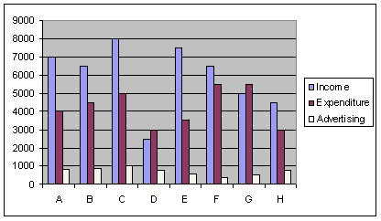

Questions...

Q1 - In this month, total expenditure was at its highest while advertising costs were at their lowest.
A
B
C
D
E
F
G
H

Q2 - This was the most profitable month.
A
B
C
D
E
F
G
H

Q3 - In this month, the restaurant made a loss, but advertising costs were lower than in the previous month.
A
B
C
D
E
F
G
H

Q4 - In this month, the restaurant made £3,000 profit and advertising costs were under £1,000.
A
B
C
D
E
F
G
H

Q5 - In this month, advertising costs were at their highest.
A
B
C
D
E
F
G
H

SOLUTIONS

Section A: Grammar & Vocabulary
Q1: more complex than humans', with about 13 more colour receptor types. Q2: faces, food sources, Q3: However, Q4: states Q5: dismantle Q6: correspondence, Q7: Research on prosopagnosia demonstrates that the brain can compensate for perceptual deficits by enhancing sensitivity in other areas. Q8: sought Q9: "Thus conscience does make cowards of us all, / And thus the native hue of resolution / Is sicklied o'er with the pale cast of thought." Q10: identified; however,

Section B: Reading Comprehension

Passage 1 (Penicillin)
- (C) The significance and development of penicillin.
- (C) Further research and collaboration were required to make it widely available.
- (B) Set the stage for the creation of antibacterial drugs.
- (B) Emphasize that scientific progress often requires teamwork.
- (B) Objective and informative.

Passage 2 (Renewable Energy)
- (B) The increasing adoption and impact of renewable energy.
- (D) Advances in technology and lower costs.
- (B) Analytical and optimistic.

Passage 3 (Industrial Revolution)
- (D) The impact and significance of the Industrial Revolution.
- (C) Economic growth and urbanization.
- (A) Neutral and factual.

Section C: Restaurant Graph Analysis

• Q1 → B

• Q2 → E

• Q3 → F

• Q4 → A

• Q5 → C

